SQL LIKE Operator

* The SQL Server LIKE operator is a logical operator that checks if a character string matches a specified pattern.
* A pattern may include regular characters and wildcard characters
* Used with WHERE Clause

Wild Cards

A wildcard character is used to substitute one or more characters in a string.

* The percent wildcard (%): any string of zero or more characters.
* The underscore (_) wildcard: any single character.
* The [list of characters] wildcard: any single character within the specified set.
* The [character-character]: any single character within the specified range.
* The [^]: any character that is not within a list or a range.

## **SQL LIKE operator examples**

### Using the LIKE operator with the % wildcard







1. Using the LIKE operator with the _ (underscore) wildcard





1. Using the LIKE operator with the [list of characters] wildcard



1. Using the LIKE operator with the [character-character] wildcard



1. Using the LIKE operator with the [^Character List or Range] wildcard

SELECT * FROM Emp WHERE Name LIKE '[^AB]%'

The SQL IN Operator

The IN operator allows you to specify multiple values in a WHERE clause.

The IN operator is a shorthand for multiple OR conditions.

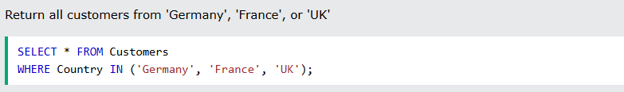

# SQL BETWEEN Operator

The BETWEEN operator selects values within a given range. The values can be numbers, text, or dates.

The BETWEEN operator is inclusive: begin and end values are included.

# 